

Change is the Only Constant:
A Multi-Modal Analysis of Voter Desire
for 'Change' in US Elections

A Thesis submitted in fulfillment of the requirements of the
Master of Data Science for Public Policy 2025

Author: Juan Pablo Brasdefer
Student Number: 225936
Supervisor: Mark Kayser, PhD.

Graduation Year: 2025
Word Count: 7,500

April 28th, 2025

Contents
List of Abbreviations iii
List of Figures iv
Abstract v
Introduction
1.1 Introduction 1
1.2 Research Question and Motivations 2
Literature Review and Contribution
2.1 Contemporary Electoral Motivators 3
2.2 Candidate 'Change' Posturing and Voter Perceptions 3
2.3 Voting for 'Change' 4
2.4 Contribution 5
Data
3.1 American Presidency Project (Campaign Text Data) 5
3.2 American National Election Studies (Voter Survey Data) 6

Study One: Identifying Change Candidates
4.1 Methods 1: Textual Analysis of Campaign Rhetoric 7
4.2 Methods 2: Static Attribute Scoring and Composite Index Construction 8
4.3 Results 1: Candidate Use of 'Change' Rhetoric 10
4.4 Results 2: Candidate Change Index Scores 12

Study Two: Identifying Change Voters and Theory Building
5.1 Methods 1: Vote Pattern Filtering 14
5.2 Methods 2: Voter Attribute Independence Testing 15
5.3 Results 1: Sample Size of Identified Change Voters 16
5.4 Results 2: Attributes Statistically Associated with Change Voting 17
Discussion: Towards a Theory of Change Voters
6.1 Towards a Theory of Change Voters 20

Study Three: Change Voter Theory Validity Testing
7.1 Methods 1: Discrete Measure, Probability of 'Change Voting' 24
7.2 Methods 2: Continuous Measure, Voter Propensity for 'Change Voting' 24
7.3 Results: Mapping Voter Propensities to Candidate Change (CCI) Scores 26

General Discussion and Implications
8.1 Discussion and Implications 28
Limitations and Future Work
9.1 Limitations 29
9.2 Future Work 31
Conclusions
10.1 Conclusions 33

Bibliography
Appendices
Statement of Authorship

List of Abbreviations
Lorem Ipsum Dolor

List of Figures
Lorem Ipsum Dolor

Abstract
Lorem Ipsum Dolor

Lorem Ipsum Dolor

Lorem Ipsum Dolor

Lorem Ipsum Dolor

Lorem Ipsum Dolor

Lorem Ipsum Dolor

Lorem Ipsum Dolor

Lorem Ipsum Dolor

Lorem Ipsum Dolor

Lorem Ipsum Dolor

Lorem Ipsum Dolor

Lorem Ipsum Dolor

Lorem Ipsum Dolor

Lorem Ipsum Dolor

Lorem Ipsum Dolor

Lorem Ipsum Dolor

Introduction

1.1 Introduction

In their 1973 song, 'Money' Pink Floyd sing "Money, Get Away, Get a good job with more pay and you'll be okay"
But Econ state last 25 years, real wage stagnation -> breaking of american dream

Similarly, the 1982 hit "Straight to Hell" by The Clash tells us "It could be anywhere, most likely could be any frontier, Any hemisphere, No man's land, There ain't no asylum here" pointing us to the increasingly global reach of wars and the devastation they bring.
In the last 25 years, Globalized world and conflicts, forever wars

Combined with the portable televisions we carry in our pockets, the average individual is in a state of constant subconscious distress

And in a world where the individual may feel increasingly powerless in their day to day, how does this distress manifest, how do they get things to change?

Though it's an un-glamorous answer, the primary way that most people get to try to change the system under which they live is through elections.
So then the question becomes, how does the distressed voter, who seeks the intangible concept of 'change', vote?

1.2 Research Question and Motivations

-> this is an important question because the 'change' voter is
1) one who prioritizes change over partisanship, and thus exists in the prized pool of swing votes
2) a demographic that is likely to grow as the economic and world situations continue to worsen
3) the 'change' voter, who votes for 'change' from a mis-identification of the aspects of their life that are subconsciously keeping them in a distressed state, is a low-info voter, meaning that they are more susceptible to rhetoric, and thus potentially more susceptible to demagogues and populists.

Through an empirics-based ranking of change candidates in last seven elections and statistical testing on voter attributes, this paper will:
->RQ: try to identify the change voter and form a theory of their motivating attributes

Literature Review and Contribution
2.1 Contemporary Electoral Motivators

Empirical

2.2 Candidate 'Change' Posturing and Voter Perceptions

Empirical

2.3 Voting for 'Change'

Empirical

2.4 Contribution

-> contribution: an empirically-founded building of theory that takes as its starting point candidate posturing and external perceptions to create a more robust indicator of change than simply incumbency y/n.
"Empirical theory formation whatever"

Data
3.1 American Presidency Project (Campaign Text Data)

The data used in quantifying the degree of 'change' that candidates attempt to sell is textual. This data is taken from the University of California Santa Barbara's (UCSB) running project, aptly titled the 'American Presidency Project' (APP). The APP is functionally a database housing an impressively comprehensive multi-media collection of documents relating to American presidential contests including texts and videos from candidates, parties, spokespeople, attack ads, and other such items. For the needs of this study, two collections were considered: A) Primary and Presidential Debate Transcripts, and B) 'Campaign Documents', which include Transcripts from Rallies, Interviews, Press Releases, and Statements.
In deciding which collections to use as the basis for a textual analysis, the Debate collection was discarded for two reasons. First, the conclusion was reached that the inherent shape and content of debate discussions were not an informative resource from which to derive candidate posturing, largely due to the fact that the debate format encourages improvisational response discussions over carefully worded posturing. Second, the small number of debates that take place in each electoral cycle and the short length of these debates creates a problem for robust analysis; in effect, there is too little data.
For this reason, the collection of 'Campaign Documents' was instead chosen as the basis for textual analysis in determining Candidate 'Change' Posturing. Add that this data was scraped from the web using xyz. This collection consists of 21,347 documents spanning seven electoral cycles (2000, 2004, 2008, 2012, 2016, 2020, 2024), within which seventy-seven speakers appear. This list of speakers includes only primary and presidential candidates.

3.2 American National Election Studies (Voter Survey Data)
The American National Election Survey (ANES) is a federally-conducted survey of the American population (across all states and counties) aimed at capturing the social and political beliefs of the population. The survey in each of its iterations (which occur every two years, coinciding with general and midterm electoral cycles) is conducted as a PRE-ELECTION and POST-ELECTION survey, where respondents are asked roughly half of the questions before the election and the remaining question after the election. Surveys consist of ~1700 total (PRE+POST) questions and, importantly, most questions change from election to election (though core themes are always present). This, paired with the cross-sectional (non-panel) format presents several challenges for the experiments in this paper, all of which are further explored in the methods and results sections. Coinciding with the APP data, ANES surveys from the previous seven electoral cycles (2000, 2004, 2008, 2012, 2016, 2020, 2024) are selected. The number of people surveyed varies across years, with most in the range of 5000-8000, while the lowest sits at 700 respondents (2000).
Unfortunately, at the time of the writing of this paper, the results for the POST-ELECTION portion of the 2024 survey have not been published, meaning that the possibility for analysis in that year is greatly reduced.
Finally, it is crucial to note that the ANES largely does not include/ share any demographic variables of respondents (age, gender, race), which greatly restricts the depth of insights that can be drawn from the results of this paper's experiments.

Study One: Identifying Change Candidates

Methods
The first experiment of this study profiles the level of 'change' posturing that each candidate attempts. To reach these profiles, two approaches are used, building on each other.

4.1 Textual Analysis of Campaign Rhetoric
The first of these is a textual analysis on candidate vocabulary. In simple terms, the idea is to look at the words that candidates use in their speeches, interviews, and press releases, to determine which candidates have most strongly focused their messaging on 'change' and its related ideas. The basis for this textual analysis is the corpus of Campaign Documents scraped from the UCSB's APP, which is then grouped by election year and candidate.

The physical text analysis is a relatively simple dictionary-based frequency count approach, which takes a set of previously-defined words relating to the topic of political 'change' and counts how often they each appear in each document. The dictionary used in this study was constructed for this paper, and can be found in Appendix A. The dictionary was built around four key topics around political 'change', " ", " ", " ", and " ", for which specific verbs and nouns were identified and stemmed. While the dictionary mainly employs Uni-Grams, several key N-Grams were also identified and utilized.
The results of the dictionary frequency matching are then averaged for each candidate to arrive at a percentage use of 'change grams', which serves as the basis for further quantitative elaboration of measures.
Importantly, no 'Stopword' or Punctuation removal was carried out, for the simple reason that this paper is not interested in the exact count of Change words used, but is instead concerned with the relative use of Change words between candidates, meaning that untethered percentages are perfectly valid for our use.

4.2 Static Attribute Scoring and Composite Index Construction

A Composite Index (CI) is an excellent tool for tackling concepts that are not easily measurable, such as the 'Degree of Change' that a candidate represents in a presidential election. The CI (referred to also as a Composite Indicator) approaches this issue by instead combining several different variables (indicators/ variables) that are related to the unmeasurable concept in an attempt to approximate its true value. For our study, we attempt to measure a candidate's 'Degree of Change', and conceptualize of it as including a candidate's 'Posturing' (the image they put forth) and their 'Attributes' (traits they don't have control over). Need to mention that we don't look at policy proposals because an assumption is that only high-info voters are paying attention to policy proposals and we have a hunch that these guys are low info.
The 'Posturing' aspect of a candidate, being the manner in which they express themselves, is derived for our study from the results the Change Vocabulary Textual Analysis, explained in the previous section. We take the 'percentage use of change grams' resulting from the dictionary-based frequency analysis, and derive a relative scoring as follows:

For each presidential general race (ie: post-primaries), i
For each year
For nominees
Find top change speaker, take the %
Divide all other speaker % by this % to arrive at their
'relative_inyear_changegrams'

The 'Attributes' aspect of a candidate is built as a combination of five 'static' or 'semi-static' personal traits, being:
A) Visible Minority - coded as 0 if the candidate is of 'white' descent, 1 otherwise
B) Gender - coded as 0 if the candidate is male, 1 otherwise
C) Age - coded as the result of taking the candidate's age at the time of the election and passing it through the following transformation:
Age Score = -log10((age_sept_election_year - 35) / 100)
Which subtracts the mandatory minimum age for candidacy (35) from the candidate's age on September 1st of the election year for which the score is being calculated, divides the result by 100, and takes the Logarithm of the result. This value is then subtracted from 1 to give our score the correct direction (ie: a younger candidate means more change, so the 'direction' has to be changed so that a lower age gives a higher score). Finally, 1 is subtracted from the result to ensure that values remain in the range [0,1].
D) Belongs to Political Dynasty - coded as 0 if anyone in the candidate's immediate family (ie: sharing a surname) has held the office of the president before
E) High Governmental Office - coded as 0 if the candidate has been President, 0.2 is the candidate has held a presidential cabinet position (Vice President, Secretary of State...), 0.4 if the candidate has been a Governor or Senator, and 1 otherwise
F) Party Affiliation Relative to Incumbent

These traits and the values given to each candidate can be found in Appendix B.

Results
4.3 Candidate Use of 'Change' Rhetoric

Figure 1 shows the results of the textual frequency for all presidential nominees in the last seven election cycles

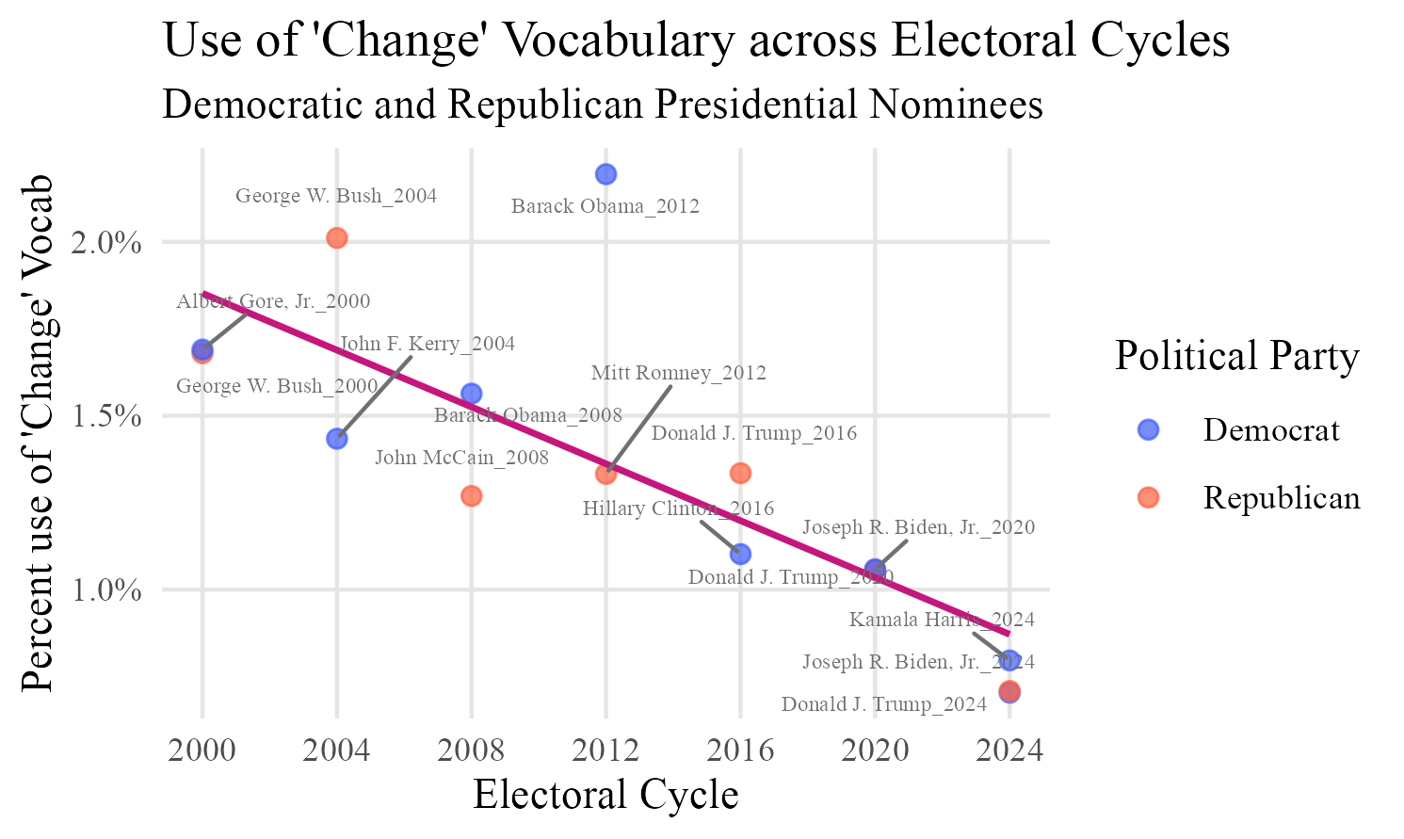

. We see first that there is no clear dominance over usage of 'Change' language by either the Democratic or Republican parties, which lends important credence to a fundamental assumption of this paper, namely that candidates in either party can run on a message of 'Change', regardless of whether the affiliated party is traditionally associated with 'liberal' or 'conservative' values/ policies. Most striking, however, is the clear downward trend we see across electoral cycles, which indicates that there has been a clear and serious decline in the use of 'Change' Vocabulary in the last seven electoral cycles. This trend is explored in the following section.

4.4 Candidate Change Index Scores

Figure 2 shows the result of the Composite Change Index (CCI) exercise, which joins together candidate 'Posturing' (campaign messaging through textual frequency analysis) and candidate 'Attributes'.

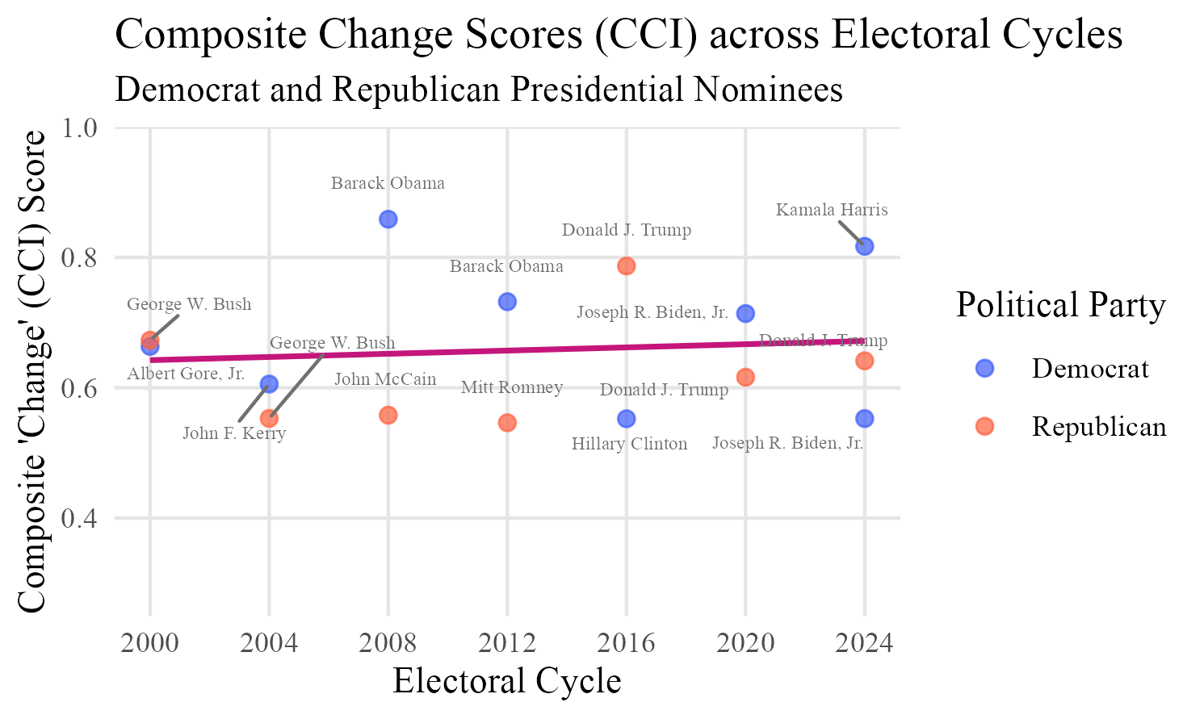

Relative to the solely-textual approach, where we saw a strong decline in the 'Change' that each candidate represented when inspecting only their vocabulary, we see now a relative increase in the overall 'Change' embodied by candidates over the last twenty-five years. This relative increase can be at least partially explained by the fact that there has been a serious widening in the pool of candidates that now run for office. Beginning with Obama's 2008 candidacy, candidates belonging to minority groups such as ethnic minorities, women, and true political outsiders have begun to enter the presidential stage. These candidates, who are a departure (visually and substantively) from the traditional political establishment, thus embody change so evidently, that their reliance on using vocabulary to communicate 'Change' has when compared to the early 2000s.
We see also that, in each election, the candidate with highest CCI was elected, other than 2004 and 2024. The 2004 election results can be partially explained by LITERATURE THAT SAYS BUSH WAS CHANGE IN 2004. Similarly the 2024 election results can be explained by the fact that HARRIS ENTERED THE RACE VERY LATE INTO THE ELECTORAL CYCLE, MEANING THAT SHE WAS UNABLE TO DISTINGUISH HERSELF FROM HER PREDECESSOR, BIDEN, AND THUS INHERITED A LOW PERCEIVED EMBODIMENT OF CHANGE, DESPITE HER OWN HIGH USE OF CHANGE VOCABULARY AND personal attributes of perceived change (such as her being a woman and belonging to an ethnic minority.

Study Two: Identifying Change Voters and Theory Building

Methods
5.1 Vote Pattern Filtering

Following the results of the first study, we make use of the new ranking of candidates by CCI ('Change') score to identify voters who follow a pattern of voting for change. The idea here is to filter respondents in the ANES survey for a given electoral cycle based on whether they voted in a pattern consistent with the results of our first study's Change Candidate rankings. We do this using the ANES survey from 2020, and and filter the dataset for respondents who reported voting in the following manner:

(2012: Obama) -> (2016: Trump) -> (2020: Biden)

Here, the 2020 ANES is used because it is the only survey that included questions asking voters to recall their previous voting choices as far back as two elections prior. In the absence of re-sampling across multiple elections, this is the closest approximation to panel data that we have. The respondents who remain in this filtered dataset are henceforth referred to as CVoters (for their pattern of 'Change Voting' across all three electoral cycles). Respondents who voted in 2020 but did not follow the pattern of Change Voting in all of 2012, 2016, and 2020 are henceforth referred to as MVoters (for the fact that their voting patterns are 'Mixed'). These 2020 CVoters and 2020 MVoters then become the basis for identifying the attributes (variables) that define a Change Voter.

5.2 Voter Attribute Independence Testing

Having identified CVoters as a subset among all voters, the goal becomes to identify the attributes that set them apart from other voters. To accomplish this, we take from the available 1700 ANES 2020 variables a set of 69 questions that represent a diversity of respondent beliefs, attitudes, and traits, pursuant to the literature and research goals of this paper. These questions (e.g. 'How favourably do you feel towards Labour Unions?') range vary between Binary, Ordinal, Categorical, and Semi-Continuous. Depending on the variable type (ie: Ordinal, Binary, Semi-Continuous), we apply a combination of three statistical tests (each of which approaches the question of probability and distributional summarization from a different point of view), with the goal of determining whether the scores of CVoters differ significantly from the scores of MVoters. In other words, we find, for each variable, whether the differences in observed values are distinct-enough between the two groups that these differences are not likely to be due to chance.
The statistical tests used are the following:

1) Independent Samples T-Test
The Independent Samples T-Test is a popular test for comparing the means of two samples under a continuous or semi-continuous variable. Crucially, since this test only considers the sample sizes, means, and standard deviations, it can easily overlook more complicated distributional behaviour. In other words, it assumes the data is normally distributed, making it a good blanket approach, but an imprecise tool when used alone. Add key measures of this test? like "it returns a t-stat..."

2) Wilcoxon Signed-Rank Test
The Wilcoxon test assesses the similarity of two samples by looking at the counts observed in each of the possible values of an ordinal variable. This makes the Wilcoxon test non-parametric, which means that it does not assume normality in the data. This makes the Wilcoxon test more resilient to distributions that may be skewed, multi-modal, uniform, or have varying levels of kurtosis, as many of our variables do.

3) Fisher's Exact Test
The Fisher's Exact is designed to work with binary variables and two groups (ie: a 2x2 frequency table) and is especially useful when there is a large imbalance of counts across groups (which is the case between our CVoters and MVoters). Fisher's returns a p-value, representing the cumulative probability of all outcomes less-likely than the observed distributions.

After applying the relevant statistical tests (all variables receive at least two of the three tests), variables with resulting p-values below 0.05 under any of the tests are taken as a positive result, and considered when formulating our theory of change voters later on.

Results
5.3 Sample Size of Identified Change Voters
From the total number of respondents in the 2020 ANES (8,280), 73% (6,029) indicated that they had voted in for president in 2020, of which 55% voted for that year's Change Candidate, Joe Biden. Of these, 86% voted in 2016, with an expectedly low 7% of those also indicating that they voted Donald Trump. Finally, 83% of these Biden->Trump voters indicated that they also voted in the 2012 election, with 57% of them having voted for Barack Obama. In total, this means that, from our original pool of 6,029 voters, 89 of them followed a voting pattern consistent with the change candidates identified in our CCI ranking across three consecutive elections. While this subset initially seems worryingly small for deriving meaningful conclusions, the fact that we use a variety of statistical tests to help in assessing significant variables, paired with a large qualitative section when formulating the broader theory at the end of this study, relieves some concerns of a small sample size.

5.4 Attributes Statistically Associated with Change Voting

Results of the statistical independence testing are shown in Figure 3, showing only the twenty variables found to have p-values under 0.05 (listed also in descending order of p-value).
We begin our analysis here by grouping these variables into five broad themes and exploring basic directional tendencies before moving to a full qualitative assessment and theory building.

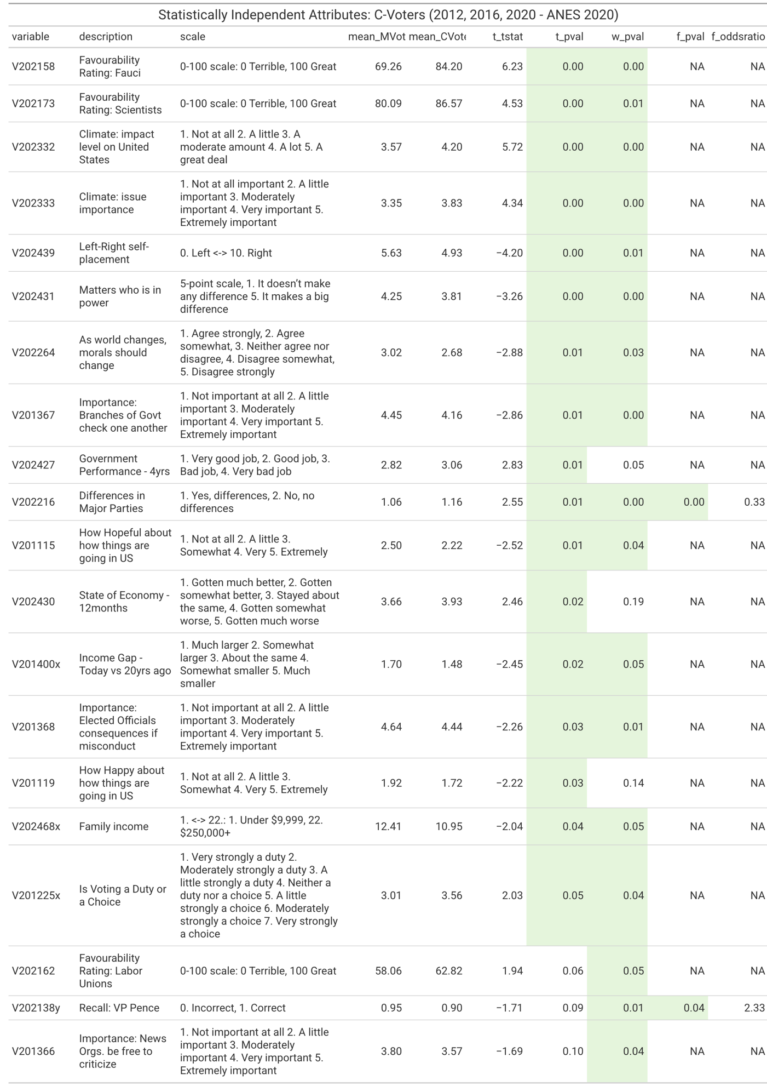
Figure 3 - Voter Attributes with Statistical Independence for CVoters

Theme 1: Economic Situation/Economic Perspective
Variables: [12], [13], [16], [18]
Conclusion: Worse Economic Situation/ Perspective
Add column for indexing variables in the table like "Variables [1], [5], and [7]"
CVoters are found to have both worse objective economic situations and worse outlooks when compared to MVoters. Family Income for CVoters on average is $7,000 USD lower, while their View of the Economy in the Last 12 Months is also worse, and their perception of the Income Gap in the Last 20 Years between the rich and poor is that the gap has grown. Finally, they tend to have a more favourable view of Labour Unions, which is discussed in the following section.

Theme 2: Belief in Science and Progress
Variables: [1],[2], [4], [7]
Conclusion: Positive view of Science and Progress
We see a strikingly high level of favourability for 'Scientists' in general and for Dr. Anthony Fauci (nearly a 15-point difference compared with MVoters). Further, we see that a greater belief in the importance of the issue of Climate Change, as well as an 'open-mindedness' in their view of how Morals should Change with a Changing World.

Theme 3: View of Future and Past
Variables: [3],[8], [11], [15]
Conclusion: Negative view of Past and Future
First, they score lower on rating 'Government Performance in Last 4 Years', which shows a negative view of the past. In the sentiment questions asking how 'Hopeful' and 'Happy' the respondent feels about 'How Things are Going in the US', CVoters score lower on both measures, indicating a discontentment with the present and prospects for the future. Finally, they tend to rate the future Impact of the Climate on the US as having more impact, solidifying a pessimistic view of the future.

Theme 4: Partisan Alignment
Variables: [5],[6], [10], [19]
Conclusion: Non-Alignment with Established Parties
First, we see a strong tendency towards the center when asked to Self-Place on a Left-Right political scale; however, a simple mean score of 4.93 for this variable may hide more interesting truths, which are further explore in the following section. CVoters tend to not believe it Matters Who is in Power, and see less Difference in the Major Parties. Importantly, their slightly lower recall of Pence's position (90% vs. 95%) hides an interesting fact that is explored in further discussion.

Theme 5: Safeguarding Democracy
Variables: [9],[14], [17], [20]
Conclusion: Relative Apathy towards Democracy
These voters tend to see issues relating to the healthy functioning and preservation of a strong democracy as less important. They rank lower on the perceived importance of having Branches of Government Check One Another, News Organizations be Free to Criticize, and Elected Officials Receive Severe Consequences for Misconduct. Finally, they see Voting as less of a Duty compared to their MVoter counterparts.

Discussion: Towards a Theory of Change Voters
6.51Towards a Theory of Change Voters

In formulating a theory of change voters, we take the results of our quantitative studies (candidate change posturing and perception -> vote-pattern filtering -> statistical independence testing) as a starting place, and refine the insights using qualitative assessment.

We begin with the theme of Economic Situation/ Perspective, and highlight the fact that the results of our independence testing has very clearly validated a central aspect of our hypothesis: the inceptive assumption of a change voter's perceived/subconscious Constant Financial Distress. This is substantiated by the fact that we saw not only one measure of economic distress in the results, but a wide variety of indicators that together point to a more interesting definition of distress. We see that these voters had not only lower incomes on average, but also a perception of the economy as getting worse and an awareness of the income gap widening, which is a correlate of the stagnation of real wages. Additionally, the timeline captured by the Income Gap variable (20 years) is further association with our own understanding of real wage stagnation since the early 2000s (citation). Finally, we remember the high favourability ratings given to labour unions, and take this (in conjunction with the observed lower average household income levels for CVoters) as signaling that CVoters may be more likely to belong to blue collar industries, where labour unions are more commonplace (citation), and where the evaporation of jobs and economic prosperity has been felt the most strongly in the American 21st century (citation). All of these taken together create solid evidence for including the Perception of Economic Distress as a central part of our Theory of Change Voters going forward.
We move to the second important aspect, which was an unspoken assumption of the paper (as it is an assumption in swing-voting more broadly), that of a roughly 'moderate' political leaning of voters. Here, however, we find that our results are far more interesting than a simple 'centrist' explanation. Figure 5, showing respondent scores for Left-Right Self-Placement, evidences this exactly.

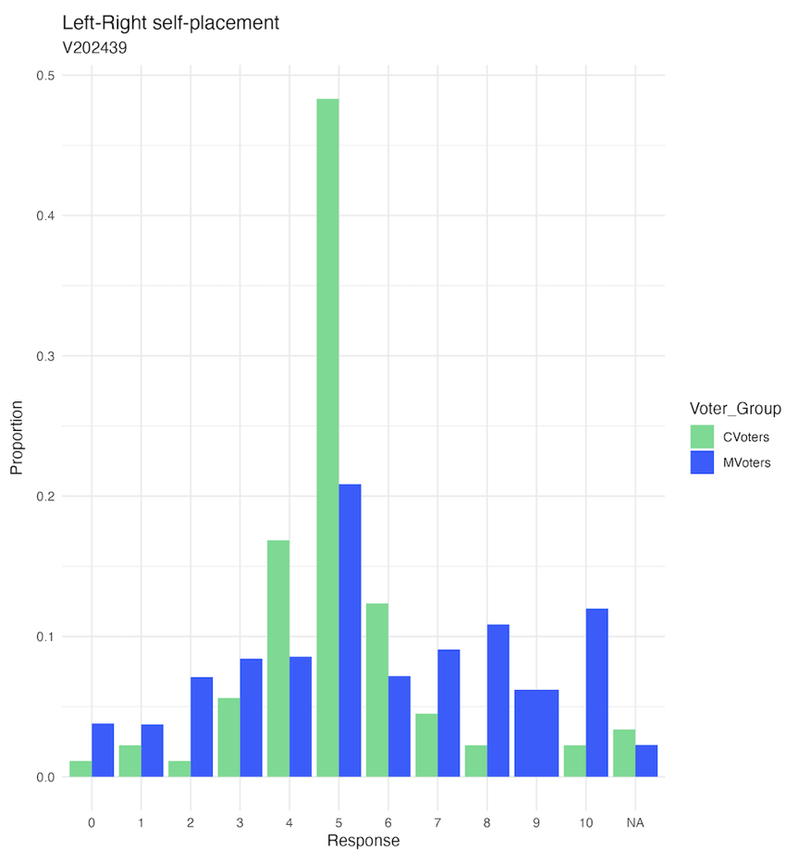

We see that CVoters are not only grouped around the center of the scale (and thus interpretable through a 'centrist' explanation when analyzing only the mean score of 4.93, mentioned earlier), but that they are in fact strikingly unimodally group around the specific response value of '5'. The sheer frequency of this value amongst CVoters, especially when compared to the less-modal distribution for MVoters, makes us understand this behaviour as not a centrist leaning, but instead as a rejection of the given political spectrum and a conscious non-alignment with the ideological values available in America's de-facto (citation) two-party system and partisan politics. This formulation of Change Voter political non-alignment is also supported by the observed attitudes of apathy towards the healthy functioning and safeguarding of Democracy in variables such as passivity towards the balance of power between the branches of government. The observed behaviours point us, then towards the second key pillar of our Theory of a Change Voter, which is the conscious non-alignment and rejection of the political environment.

Finally, we lean on the results (and non-results) of the Office Recall and Science questions to formulate our final pillar.
First, we speak on the fact that, of the four 'Office Recall' questions (Pence, Pelosi, Merkel, Roberts) included in the original 69 variables passed through the independence testing of this study, only one (Pence) gave a significant result in the direction of our original hypothesis: that Change Voters would be lower-(political)-information individuals. This is a fundamental difference of what was expected in the results, and so forces us to reconsider the presence of information and political knowledge in the Change Voter. Supplementing this new view of Change Voters, we take the high favourability ratings for 'Scientists', belief in Climate Change, and positive view of Dr. Anthony Fauci as further evidence in the direction of these voters being higher-information (or at least now 'low-information) individuals.

Observing our Economic, Ideological, and Informational pillars, we can thus formulate a single, unified Theory of Change Voters, which describes Persistent Economic Distress, Conscious Non-Alignment, and Informational Non-Absence (Adequate Political Knowledge? Information Levels?)

Study Three: Change Voter Theory Validity Testing

Methods
Following our quantitative and qualitative formulation of a Voter Change Theory, we apply it to earlier ANES (< 2020) to assess the validity of the theory. In doing this, two methods were devised:
1) Discrete Filtering of Voters to arrive at probability of choosing Change Candidate
2) Change Voter 'Scoring', Continuous measure of affinity for change, to assess propensity of voters for choosing change candidate

7.1 Discrete Measure, Probability of 'Change Voting'

1) Discrete Filtering of Voters to arrive at probability of choosing Change Candidate
Consists of filtering dataset using selected variables to arrive at subset of respondents who fit the attributes of a change voter EXACTLY. Then calculating the probability (simple percentage) of voting for change candidate.
Probably Send this discrete measure to appendix and just mention it briefly?
This was tried with two sets of filtering variables.
One was the INCLUSIVE, which used all five categories found in the results of the Stat. Indep. Testing. This approach proved too restrictive, even when expanded to include two variables in each category filtered using OR logic (so as to make it less intensively rules-based). Variables used, logic, and results can be found in Appendix 7
The second set was PRECISE, using the variables identified in the Change Voter Theory, but retained a strict filtering approach. Similarly to the INCLUSIVE approach, this approach proved too reductive, even resulting in a miniscule sample of 12 respondents in the year 2000, making any meaningful analysis impossible, and conclusions feeble. Results for this can be found in Appendix 7.

7.2 Continuous Measure, Voter Propensity for 'Change Voting'

2) Change Voter 'Scoring', Continuous measure of affinity for change
Given the flawed nature of a discrete filtering approach, a continuous measure was instead proposed.
The benefits of this approach is that it does not filter any respondents from the dataset, but instead gives each a 'score', from which we can derive overall insights.
This 'Change Voter Score' is composed of the following:

Variable Categories coming from Theory of Change Voters
For each Category, one variable is chosen that best reflects the theorized aspect that the category is meant to capture.
Economic -> Income Gap
Several variables were considered, including HOUSEHOLD INCOME, US ECON LAST 12 MONTHS, and INCOME GAP 20 YEARS.
20 YEARS chosen because it 1) closely reflects a WORSEING ECONOMIC ANXIETY, 2) is agnostic of INCOME LEVEL, which has been shown to be highly correlated to party lines (Dem issue until 2012, Rep from 2016 onwards) (citation), and 3) has a broad scope, not solely focused on the past year.
Note: For the year 2000, this question was not asked (nor a different formulation of this question, such as in 2004). In its stead, the question "US Econ in past year" is used. A full list of questions in each year and their scales is found in Appendix H. (var_ref_table).
Partisan Non-Alignment -> Left-Right Self
Left-Right for whatever reason. Others considered were Lib-Con, Trust in Washington, Thermometer of Reps, Thermometer Dems

Note: For the year 2000, this question was not asked (nor a different formulation of this question). In its stead, the question "Self Placement Lib-Con Scale" is used. A full list of questions in each year and their scales is found in Appendix H.

Information Level -> Office Recall
Office Recall for whatever reason. Others considered were Attention to Politics (but Attention =/= Information level, and also doesn't capture the informed but burnt out voter who is tired of listening to politicians, knows a lot, but just wants change), Listen to Pol Radio Talk Shows (but diminish in use between 2000 and 2020).

For most years, this is Office Recall SPEAKER OF THE HOUSE

Note: For the year 2008 all responses to OFFICE RECALL questions are restricted to the viewer, meaning that they are not usable. In place of SPEAKER OF THE HOUSE, "How close attn to politics and elections" is used.
Note: For the year 2000, SPEAKER OF HOUSE is not asked. In its stead, the question "so PM of Britain Tony Blair" is used. A full list of questions in each year and their scales is found in Appendix 8.

Scoring
Respondent values for each of these variables are then 'scored' depending on the available categories in each variable, similar to the CCI developed for candidates.
These mappings can be found in Appendix 9?. In terms of scoring direction, voters receive higher ECON scores who note a larger income gap, higher LEFTRIGHT scores the closer to the center the respondent is (with extreme left or extreme right voters receiving gradually lower scores, in a 'folded scale'), and higher INFORMATION scores to voters can accurately identify the office (position) of the politician in the survey question.

These three variable scores are then weighted according to the below scheme:
changevoter_score = (0.5* score_economic) + (0.35 * score_leftright) + (0.15 * score_informed)

This weighting scheme is a reflection of the central stance of this paper, which is that the adverse and disproportionate effects on regular Americans of Real Wage Stagnation in the 21st century has created a constant state of economic anxiety and general distress in the median voter, which in turn leads them to choose the candidate most likely (in the voter's perception) to deliver change. Thus, the economic score is weighted most heavily, followed by the partisan non-alignment score, and lastly the information score, which receives the lowest weighting due to the fact that it comes from our qualitative theory formulation and has little empirical basis in the results of our second study. Need to mention also different weighting schemes tried (ie: that +- 5% changes across weights did not change results, meaning this is a stable center of weights).
In theory, the resulting 'Change Voter Score' thus describes the propensity of a voter to choose the Change Candidate in the given election year. The validity of this propensity is examined in the results section.

Results
7.3 Mapping Voter Propensities to Candidate Change (CCI) Scores

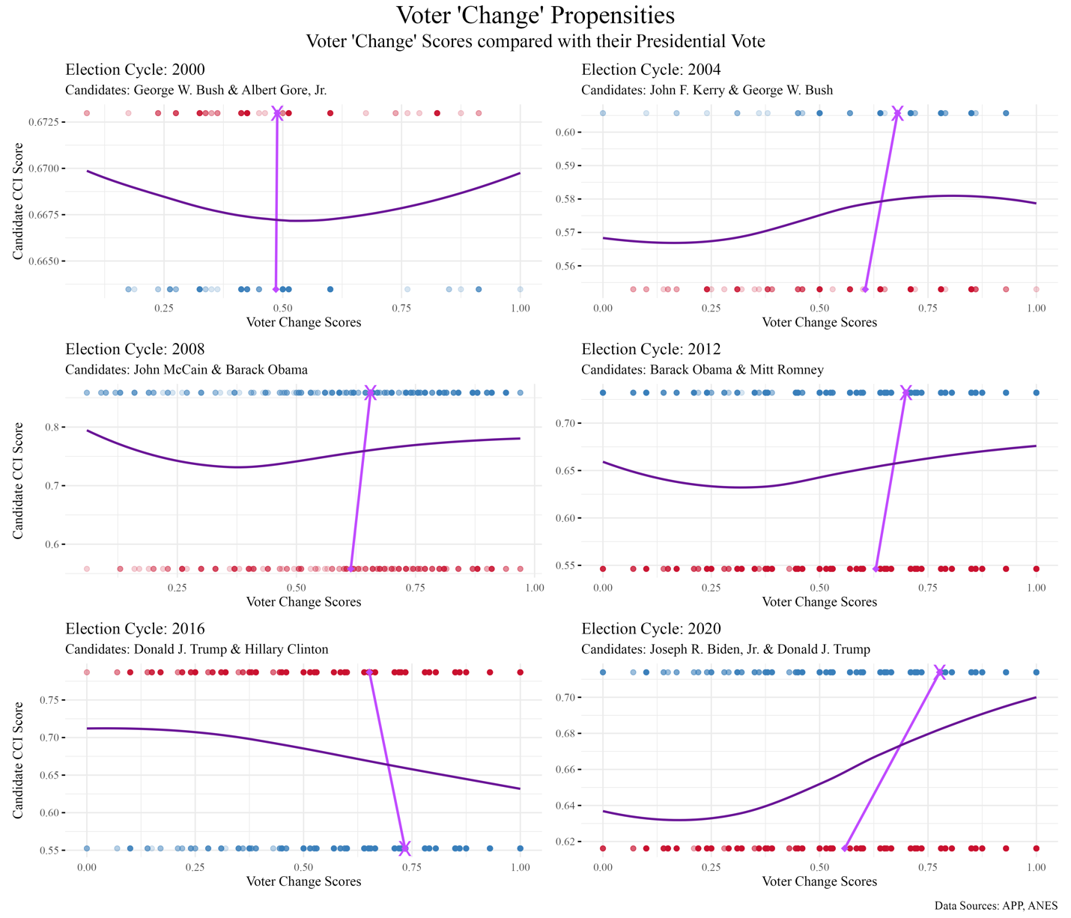

Ok so key points for this section are
Explain how the graph works by taking the example of 2020 Biden and Trump.
X axis shows distribution of Voter Change Scores, with transparency showing frequency.
Dark Purple Line - LOESS (Locally Estimated Scatterplot Smoothing) line gravitates towards where there is a greater concentration of points. Visually, we can interpret it as a reverse density function, where a lower 'density' of points is reflected with less 'height'.
NEED TO MAKE THE Y AXIS ONLY SHOW THE CCI VALUES OF THE CANDIDATES (ie remove other tick labels), otherwise it's too confusing and cluttered. Or maybe we try their names again?
Y axis shows the CCI scores of the republican and democrat candidates in the presidential race. The candidate on top is always the one with a higher CCI.
Light purple Chord Lines - joins together the Mean Voter Change Score for each of the two candidates, and the light purple 'X' denotes which of the two Mean Scores was greater. In other words, the 'X' tells us which candidate's voters were more 'Change'-minded. Whose voters had, on average, higher Voter Change Scores. Example, Bush 2000: very vertical, which speaks to the fact that the election was so close between Gore and Bush.

Basic Trends: For all except 2016, the change candidate's voters had a greater propensity for change, illustrated by the fact that the average of Voter Change Scores is greater for the candidate in each election with a higher CCI score.

Shape of LOESS lines--
Bush 2000: very parabolic, meaning he captured the voters with lowest change and highest change propensities (makes sense, since he played 'compassionate conservatism', so conservatives still went for him, and he was country club republican, so rich people [less likely to score high on economic worries] voted for him)
In 2004, we see an 'S' (almost logistic) shape meaning that, as voters became more change-minded, they became more likely to vote for Kerry.
Obama has a very interesting pattern here, in that his LOESS curves for 2008 and 2012 are exceedingly similar in shape, and differ effectively only in 'intercept'. Their shape tells us that the make-up of his base was similar in both elections (capturing both low-change and high-change voters, but losing out on medium-low-change voters), while the lowered intercept in 2012 illustrates the fact that win-margin went from 7% in 2008 against McCain to 4% in 2012 against Romney.
In 2016 we see the only result inconsistent with the expected voting pattern, showing that voters with higher propensity for change actually had a greater probability of voting for Clinton, who was decisively not the change candidate in 2016. Two explanations for this may exist. First, that polls and surveys for the 2016 election famously under-surveyed the demographics that ended up voting for Trump (citation), largely because Trump succeeded in forming a new coalition of voters (citation), many of which had not been voting in previous elections. Logically, this could mean that an important portion of the people that voted for Trump in 2016 are simply not represented in the ANES survey of that year, which is further evidence by a mismatch in the real-world popular vote margin and the one found in the ANES 2016 dataset. Second, that our CCI measure is imperfect (which it certainly is), and is severely underrepresenting the appeal that Clinton being the first-ever woman to reach the presidential stage had for Change-Propense Voters. For some voters looking for change in 2016, Clinton's gender may have been the quintessential indicator of 'change'.
Finally, in 2020 we see the most stark behaviour in the LOESS curve between Biden and Trump. Here we see Trump, a particularly divisive incumbent who was dealing with the onset and aftermath of the first wave of the Covid-19 Pandemic in 2020, perform terribly among voters with higher change scores (VCS?), with Biden taking these voters comfortably.

General Discussion and Implications
8.1 General Discussion and Implications

Tough to say whether our hypothesis is true. The reality of real wage stagnation is having massive effects on electorate make-up, no doubt.
Our approach is good, but flawed.

Parties need to see that yes it's 'the economy' but it's also a more significant understanding of the economy and of the functioning of society in an advanced, globalized democracy. Winners and losers. We see in nafta rhetoric. Some left behind while other rising exponentially. Coast vs heartland. Left behind by political establishment. It's not just because people didn't understand the threat that trump posed to democracy, it's that they didnt care. They believed he would bring change more credibly than Harris, and so he won.

LIMITATIONS and FUTURE WORK
9.1 Limitations
Change is not defined the same for everyone. Many people may consider themselves 'change' voters, and be voting for different types of 'change'. An example could be our failure to correctly assess Clinton's appeal in 2016 and the fact that, for some people, the mere fact that she was a woman was more than enough to see her as the candidate of 'Change'.

If our hypothesis is true, that change is becoming a greater phenomenon and change voters more prevalent, then future elections hold more value for study, meaning that we can't fully prove the validity of the theory yet. For example, will we in 2028 have our first openly-gay candidate (Pete Buttigieg)? Or will it be the second election in a row with a woman on the presidential stage (Alexandra Casio-Cortez)?

Separation from incumbency?

Different variables across ANES makes being methodological very difficult.

Change voter theory we develop is quite basic in that we only test using three variables, but as was discovered in the discrete validation tests (ie: filtering ANES other years), the dataset doesn't allow us to filter for many more variables at once, because there are not enough respondents. So, a theory could be expanded with new or different data.

ANES has no demographic. Maybe need Cooperative Election Study

9.2 Future Work
Textual Analysis - Use word embeddings instead of a static dictionary

Going deep instead of going wide (Analayze one or two docs per candidate more deeply, such as TF-IDF) instead of simple frequencies on many documents

Conclusions
10.1 Conclusions

Econ validated, Left-Right added, Info disproven. We also gain something about the not caring much about democracy as a self-evident issue to care for (sorry Fukuyama. a-la "I guess it's not self-evident after all").

More closely examine the role of independents in the political system/ selling change/ taking legitimacy away from Dem/Reps attempting to sell change. Examine more closely than is done in Appendix G with discrete probabilities etc.

'Speaker' indicates the primary speaker in the document, and is a tag taken directly from the APP UCSB data, not inferred or devised. For example, in a Wisconsin rally in 2024, congresswoman Liz Cheney gave opening remarks before Kamala Harris took the stage, but Harris will be noted as the 'speaker' of the document. The effects of this textual make-up of documents is further discussed in the methods section.
'Stemming' in the context of Text Analysis typically means shortening a word to its basic character stem. For example, "innovation" and "innovate" are both shortened to become the same stem, "innovat". Distinct from Lemmatization, Stemming does not aim to find the 'Lemma' or 'correct base word' (such as "swim" for "swimming"), but instead the shortest character version of the word that retains unique spelling across all other stems.
Uni-Grams being single-word objects ("forward", "establishment"), as opposed to Bi-Grams ("looking forward"), Tri-Grams ("drain the swamp"), or N-Grams for any number N.
While this age-transformation equation works great for our purposes, it is far from ideal, namely because it breaks down (exceeds the necessary range of [0,1] quite easily. With a 45 year-old candidate, the result is 1, but with a 36 year-old result you get 2. With 35 you get an impossible equation because you can't take the log of 0. A better equation would be ________________, but it did not serve enough of a distinguishing effect on the older candidates, so it was replaced with the current equation.
Results for all other candidates and other political parties for these election cycles can be found in Appendix C.
ANES Panel Data does technically exist for 2016-2020, but it does not increase the number of elections captured via vote-recall questions relative to our current use of only the 2020 ANES. For this reason, and for reasons of poor consistency among questions asked across surveys, we continue with the 2020 survey for this study.
Large portion of these are administrative. The true number of question asked that are not admin, experimental formulations, duplicates, etc. is about ~400 variables. Admin Variables: self explanatory Metadata Variables: governor name in race for state (not rly q) Pre Variables: Intention to vote for... Preference for House (too specific: Low response and difficult generalizability) Open-Ended Answers: doable with text analysis, but few responses and sometimes not attached in encoding Very Election-Specific Questions: like feeling on border wall Repetitive Questions: (rephrasings)
Found in Appendix D
p < 0.05
Include formulas in appendix?
This would be clearer in a table, if you have the time.
Given that Joe Biden and Donald Trump belong to different political parties.
More detailed filtering results can be found in Appendix E
An interested reader may consult Appendix F, which contains graphical representations of each of these variables, showing distributional details beyond simple statistics.
Coded average values of ~12.4 for MVoters and ~11.0 for CVoters map to the ANES income scale as 11: $60,000-64,999,12: $65,000-69,999
Chief Medical Advisor to the President when this survey was conducted.
As industry becomes increasingly extractive, inflationary, and price-gouging, the profits taken home by the ultra wealthy increase at a rate higher than the incomes of the median.
This would also explain their voting for Joe Biden (a famously blue-collar and labour union candidate [citation]) in 2020, and perhaps prime us to believe that they would have voted for the manufacturing candidate, Donald Trump (citation), in 2024.
On this idea, the variables identified as belonging to the theme of Perceptions of Future and Past correlate heavily with (and are arguably founded in) economic distress. The observed negative outlook that CVoters hold on the future (Hope) and low satisfaction with the present (Happiness) further validate the theory of a strong desire for change, but for the purposes of our theory, we wrap these results into the broader idea of Economic Distress as, in our theory, Economic Distress is the inceptive source of distress and is arguably a confounding variable on voter 'Outlook' and 'Wanting Change'(would need citation?).
Note: The probability of Change Voters choosing independent parties/candidates is briefly studied in Appendix G, which attempts to describe the discrete probability of voting for candidates across different elections. Though the question of independents in the American system is fascinating and important, it is outside the scope of this paper, and thus not fully explored.
Importantly, this observed apathy towards in Change Voters towards the safeguarding of Democracy is consistent with Harris's failure in 2024 to convince the electorate of Trump's existential threat to Democracy, resulting in her loss (in a contest where she foreseeably could still have won as the 'Change' candidate, given her gender, race, and late joining of the contest).
Chief Justice of the SCOTUS
Though these belief in science indicators do help us cement the informational aspect of voters, we do not include these scientific themes in our unified theory as a standalone pillar, as 'Scientists' played an outsized role in the 2020 election (given the Covid-19 Pandemic) and a belief in Climate Change is traditionally (and still) heavily associated with Democratic voters (citation), distracting from our central goal of theorizing a phenotype that is agnostic to political partisanship and identifiable across many electoral cycles.
Clinton received 48% of the popular vote in 2016 and Trump 46%, which is a 2% margin. Meanwhile, the ANES 2016 dataset paints Clinton as having a margin of 4%, indicating that there may be a systematic error in the sampling employed during the 2016 ANES, which contributes to these bizarre 2016 Change Voter results.
And the campaigns heavy reliance on this theme, seen clearly by the slogan "I'm With Her" (Citation)
Disregarding the fact that her husband had been president for eight years between 1992 and 2000, that she had worked as Secretary of State under Obama, and for many, embodied the 'political elite' of Washington (Citation).

